**Talk With A Chatbot!**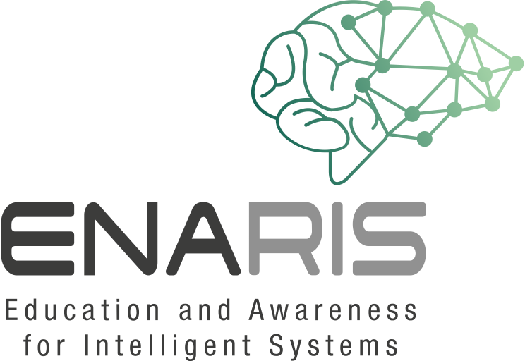

Form groups of 3-4 people

Take a closer look at the **chatbot Mitsuku (nickname Kuki)**!  
**https://chat.kuki.ai**

Log in and solve the following exercises.

Stop the time while talking with Mitsuku!

**How long does it take for you to realize that this isn't human? How did you recognize that this is a computer system?**

* What happens when statements are repeated?
* What happens if you phrase the same question differently?
* How can you tell that you are talking to a machine?
* Does the chatbot always give logical answers to your questions? How does the chatbot react if it doesn't understand something?
* Do you have to write whole sentences or are single words enough for the chatbot? Does he interpret these individual words correctly?
* Provide precise examples/quotes from your conversations with the chatbot! What could be done better, so that it does appear more human?
* Should it even appear more human?