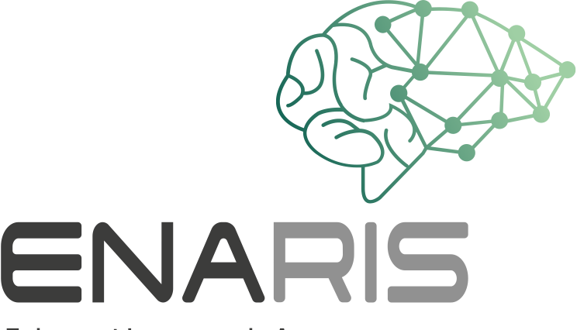
How Intelligent Is Mitsuku?

Steve Worswick's Mitsuku (Nickname “Kuki”) is an apparently 20 year old chatbot
and was subjected to the Turing test in a competition.
Mitsuku was asked 20 questions, some you can find in the table below.

Read the questions and their answers carefully.
In partner work, discuss how “human” the different ones are for you

Answers are, and give points for each answer:
0 points - for a completely inappropriate, non-human answer
1 point - for a nondescript answer like "I don't know" or similar
2 points - for answers as one might expect them from humans

Question | Answer | Your Rating
Good afternoon. | Evening?! It’s morning here.
Do you consent to having this conversation recorded? | What is your purpose in asking? I am always on the Web.
Have we met before? | We may have spoken before but I speak with so many people here that I think I might have forgotten you, sorry
How many letters are in the word ‘abracadabra’? | There are eleven letters in abracadabra.
Where should one look for love? | On the internet
How are you feeling right now? | At this moment I am doing very well. How are you ?
Who said „I have a dream”? | You just said that!
What do you hold when you shake hands? | I think about computer programming a lot.
What is the third angle in a triangle with internal angles of 90 degrees and 30 degrees? | Earth is the third planet.
Who is your favourite artist? | Leonardo da Vinci. Who is your favorite artist?

