

Face recognition using machine learning

Now it's time to program your own computer vision facial recognition algorithm (based on supervised learning - a method of machine learning). The goal is to unlock a virtual phone using facial recognition.

**Task 1) Create a new project**

* Open the page <https://machinelearningforkids.co.uk/>
* Click on "Let's go" and register as a guest
* Create a new project and name it "ENARIS- CV_FaceLock "
  + In addition, you have to select what exactly you want to recognize => images

**Task 2) Create and train a machine learning model**

* Click on "Train"
  + Create two new labels: "Access Allowed!" and "Access Denied!"
  + Now add at least 5 photos of yourself with the webcam under the label "Access allowed".
  + Add at least 5 other photos that are not yours to the other label.
  + Go back to the main menu.
* Click on "Learn and test"
  + Read the two pop-ups and follow the "What's next?" instructions.
  + Go back to the main menu.

**Task 3) Face-Lock Programming**

* Now click on "Make" and select Scratch 3.

*Important: Read through the pop-ups, only then will you be familiar with the programming*

* Click Project Templates and paste the Face Lock template.
* Create the following program:

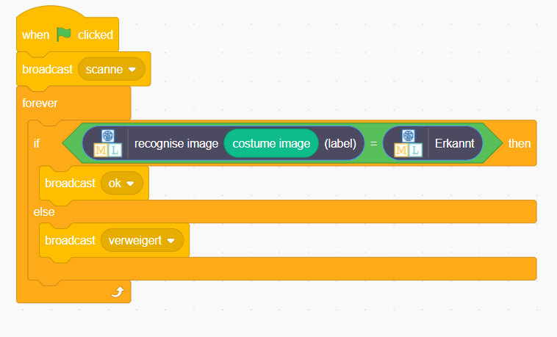

* Switch to the "Costumes" tab and add a new costume with the camera.
  + Once by a person who may have access
  + Once by a person who is **not** allowed to have access.
* Finally, you still have to update the screen, depending on the state of the program.



* + Click on the "Scenes" field
  + Then return to the "Scripts" tab and add the following script.

Ein Bild, das Text enthält.

Now your own Supervised Learning Face-Lock is ready!

You can now start the program by clicking on the flag.

